Russian Hydrometeorological Data Sets for Northern Eurasia

V. N. Razuvaev, O. N. Bulygina

All-Russian Research Institute of Hydrometeorological Information -
World Data Centre (RIHMI-WDC)
6 Korolev St., Obninsk, Kaluga Reg., 249035, Russian Federation

Climatic data serve the basis for studying climate and its variability. The study of regional features of climate variability is of increasing importance against the background of global warming.

RIHMI-WDC has the State Hydrometeorological Data Holding. A sufficiently dense network of meteorological stations is located on the Russian territory (Fig.1). Northern regions have fewer stations and more problems. The variation in the number of the stations is shown in the Figure 2. The maximum number of the stations was recorded in the 1980-s. Currently there are about 1 500 active stations in Russia.
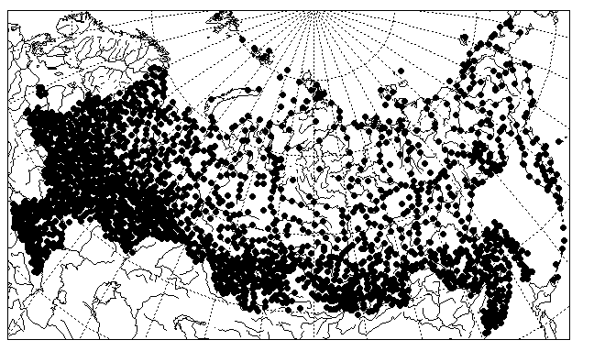
Fig.1. Russian meteorological stations

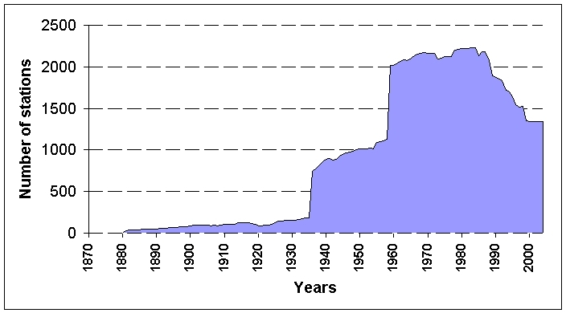
Fig. 2. Variation in the number of the russian stations

Meteorological data arrive at 25 regional centres. Data processing and data input are performed by Climatic Data Base Management Systems. The regional centres make the data available to RIHMI-WDC. Data are recorded on advanced machine-readable carriers.

Data quality control is important problem. In creating historical meteorological series, particular attention is to be given to data quality control and elimination of data inhomogeneity. There are different reasons for data inhomogeneity in Russia. On the one hand, this is due to the change in the observation procedure (change in observation frequency).Before 1936, observations were made three times a day, from 1936 to 1965, four times a day, and since 1966 observations have been made every three hours. Therefore, meteorological data archives for different periods are of different structure and in different formats (Fig.3).

Years | Times\day
1891 - 1935 | Three (7, 13, 21 Local Time)
1936 - 1965 | Four (1, 7, 13, 19 LT)
1966 - 1976 | Eight (3, 6, 9… Moscow Time)
1977 - 1984 | Eight (3, 6, 9… Moscow Time)
1985 - 1992 | Eight (3, 6, 9… Moscow Time)
1993 - now | Eight (3, 6, 9… Greenwich Time)

Fig. 3. Change in observation frequency.

Data homogeneity is also disturbed by the replacement of instruments (rain-gauge by precipitation gauge), the change in meteorological data processing procedures (e.g. introduction of wetting corrections into precipitation observations, changes in codes of visibility (Fig.4.)) and displacement of meteorological stations.

 | Before  1947 | 1947-  1949 | 1950-  1959 | 1960 –  now
Code | Visibility  (m) | Visibility  (m) | Visibility  (m) | Visibility  (m)
Х0 |  |  | >20
Х1 |  |  | 20
Х2 |  |  | 40
. . .
X9 |  |  | 180
00 |  | <10 |  | <100
01 |  | 10 | 200 | 100
02 |  | 20 | 400 | 200
03 |  | 30 | 600 | 300
04 |  | 40 | 800 | 400
80 |  | 20000 | 16000 | 30000
. . .

Fig.4. Changes in codes of visibility ( Example )

It seems impossible to solve the problem of obtaining high-quality meteorological data at the same time for the whole meteorological information available. The amount of data, their organization and the existing problems make it impossible to do.

Therefore, the first stage in implementing any climate research project is to create the required database.

The historical database creation includes the following:
- Formation of metadata sets of the appropriate stations.
- Elimination of inhomogeneity in meteorological data series that is caused by the change in observation and processing procedures, instrumental change, etc.
- Ensuring the opportunity of regular updating of data sets with current data.

Apart from recovery and preservation of data in the Holding’s data archives, we consider it vital to make meteorological data of Russia accessible to the world scientific communities. International projects and bilateral cooperation contribute to the solution of this problem. The following data sets can be used as an example of specialized climatic databases:
- Data set of snow characteristics for 223 Russian stations and data on route snow surveys (1200) which are created in implementing the project INTAS-Snow Cover Changes Over Northern Eurasia During the Last Century: Circulation Consideration and Hydrological Consequences (SCONE).
- Daily precipitation data set for stations in the former USSR (TD-9813) created within the framework of bilateral cooperation (between RIHMI-WDC and NCDC).
- Data set Daily Temperature and Precipitation under the project European Climate Assessment (ECA), 2000.

Special attention should be paid for preparation of the specialized data sets for NEESPI purposes.

