Changes in snow cover characteristics over the Russian territory in recent decades
O. N. Bulygina , V. N. Razuvaev

All-Russian Research Institute of Hydrometeorological Information -
World Data Centre (RIHMI-WDC)
6 Korolev St., Obninsk, Kaluga Reg., 249035, Russian Federation

The state of snow cover is one of the most important characteristics of the regional climate.
The present work studies snow variations by using empirical and statistical analysis of time series of snow depth daily data.

Data
Regular snow cover height measurements at stations were started in Russia in 1902 and modern snow survey observations, including snow water equivalent, in 1966. Time series of snow depth daily data on the extent to which the near-station territory is covered with snow for Russian stations is prepared at RIHMI-WDC. These data and time series of snow survey data at 450 stations were used for investigation of variations in the most important characteristics of snow cover in recent decades. Since then a lot of corrections in methods of observation have been made and special attention was paid to collection of all possible sources of inhomogeneities in data. Unfortunately many of these metadata are in listing form until now. Homogeneity disruption is largely caused by the change in snow observation procedures, including the selection of observation sites; the last substantial change in the requirements for the site selection took place in 1950. Thus the homogeneity of snow height data for 1951-2006 was not affected by the changes in observation procedures.

Procedure
1) The following is calculated for each station:
- the number of days in a year with snow height >1 cm, from July to June;
- the number of days in a year with snow height >20 cm, from July to June;
- mean annual snow height, from July to June
- the number of days in a year with over 50% of the area around the station covered with snow, from July to June;

2) Linear trend coefficients are calculated for each station for the period 1951-2006 and 1977-2006

Results
The study of the snow cover on the Russian territory revealed regional features in the change of snow cover characteristics
To characterize snow cover duration a number of days with more than 50% of the near-station territory covered with snow and the number of days with the snow deps more then 1.0 cm were used (Fig.1). The tendency for the decrease in this characteristic for 1951-2006 is found in the western and southern regions of European Russia, The decrease in snow duration was recorded in the Taimyr Autonomous District and in the Altai Territory (4 to 6 days/decade) and in the Tyva Republic. Most of East Siberia is occupied by the zone of positive trends with the maximum values attained in the northwest of Yakutia, central and southern regions of the Krasnoyarsk Territory and in Chukotka (4-6 days/decade).

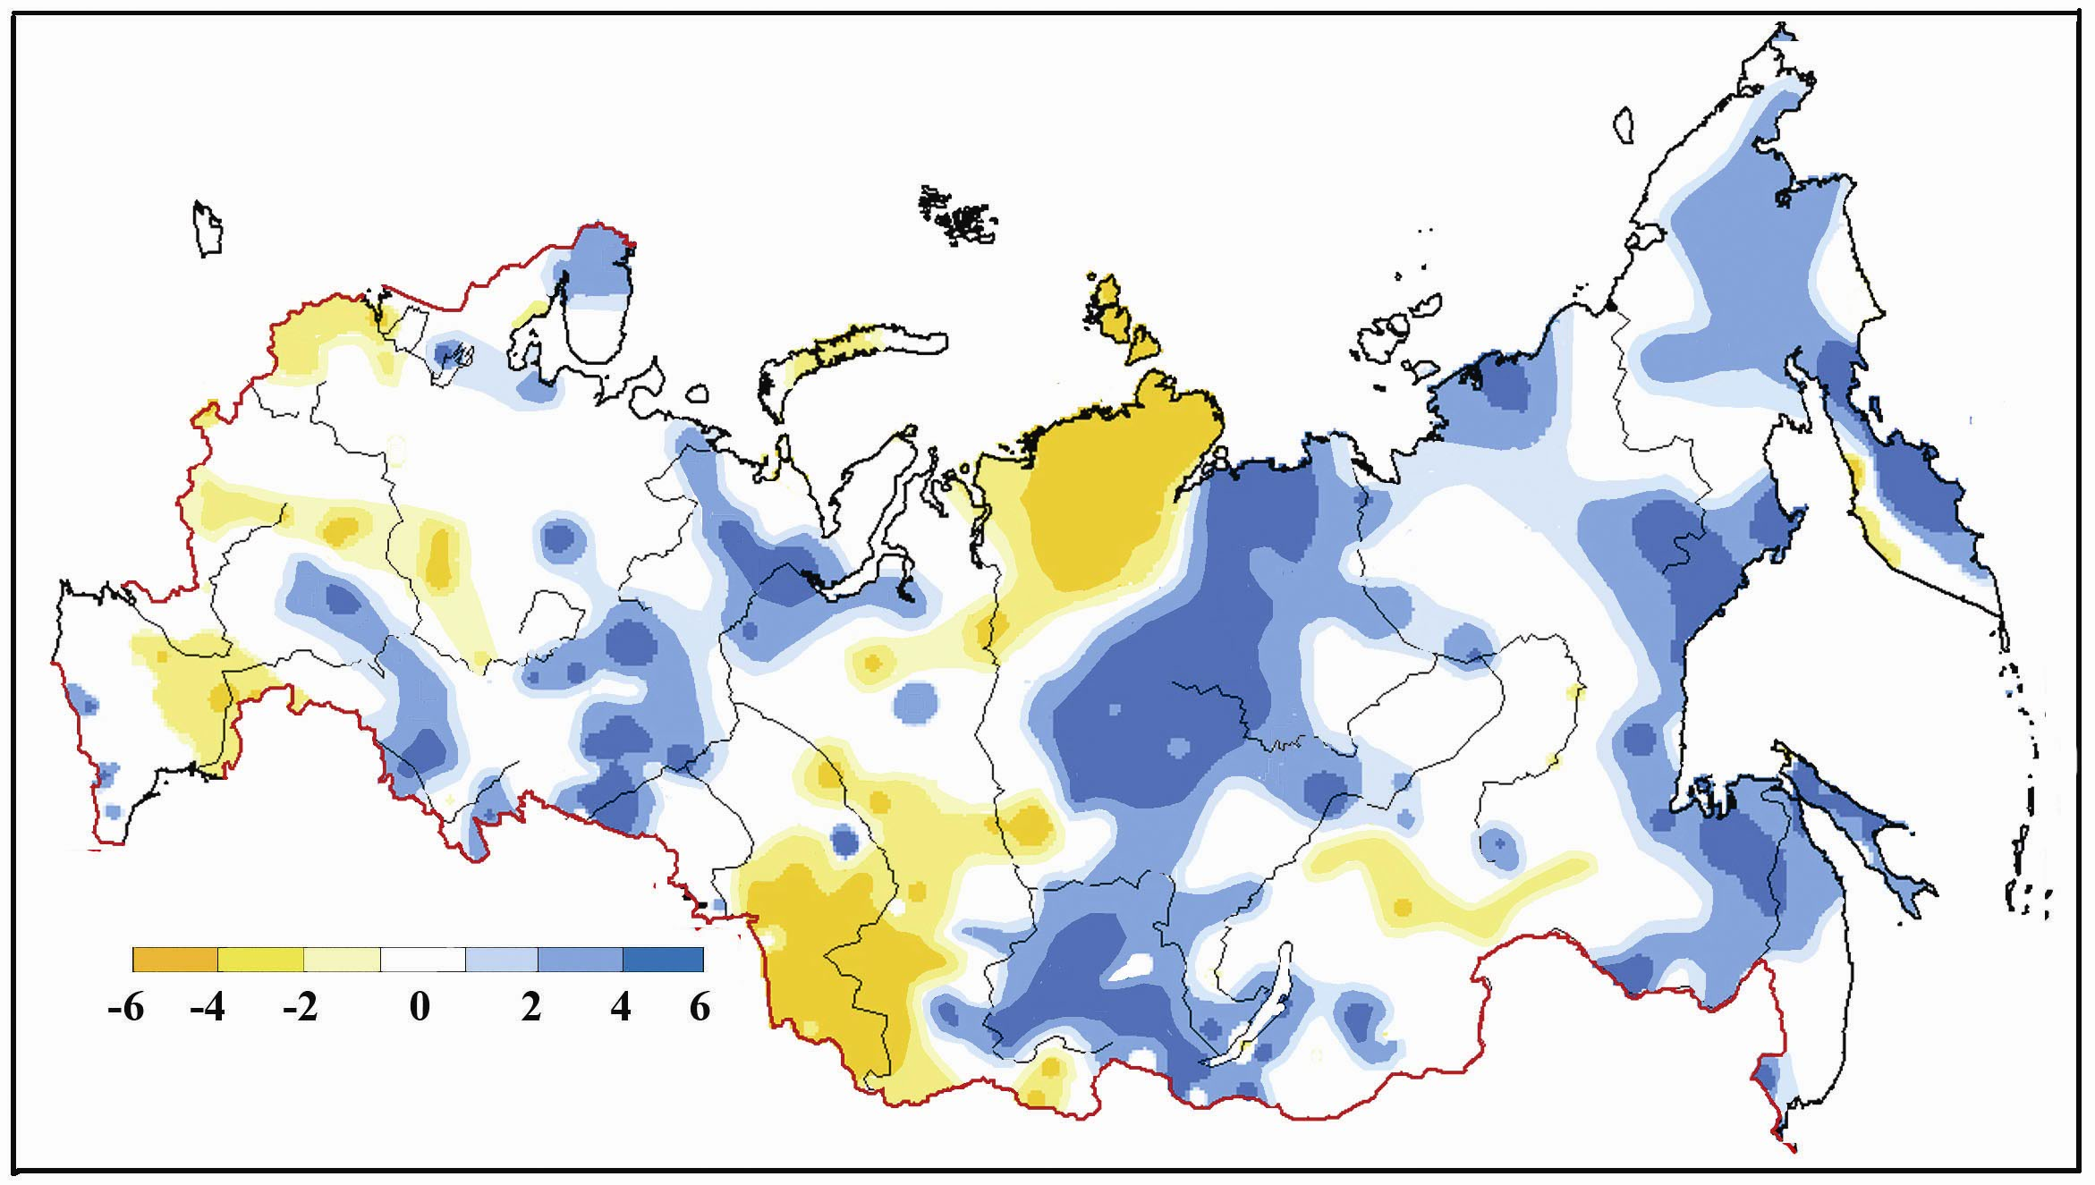

Fig.1. Linear trend coefficients in the time series of the number of days with snow cover exceeding 1 cm for 1951-2006.

Over most of Russia the number of days with snow height of more than 20 cm also increased, in some of the regions the increase being rather considerable (Fig.2.). Throughout the Arctic coast, from the Kola Peninsula to Taimyr, the linear trend coefficients were 6-8 days/decade. The same values were recorded in the east of the European territory, the south of West Siberia, the east of Yakutia, the Amur lower reaches, and Sakhalin. On the other hand, the number of days with snow height of more than 20 cm decreased in Transbaikalia and the Chukchi Autonomous District (4 to 6 days/decade).
In the series of the winter mean snow height for 1951-2006, positive trends were prevailing, which agrees with the above estimates. Maximum values of linear trend coefficients were obtained for the northeastern regions of European Russia (Nizhnyaya Pesha, see the inset in Fig.3.), the south of West Siberia, northern and central regions of the Krasnoyarsk Territory, and Sakhalin. However, some of the Russian regions show decrease in this parameter

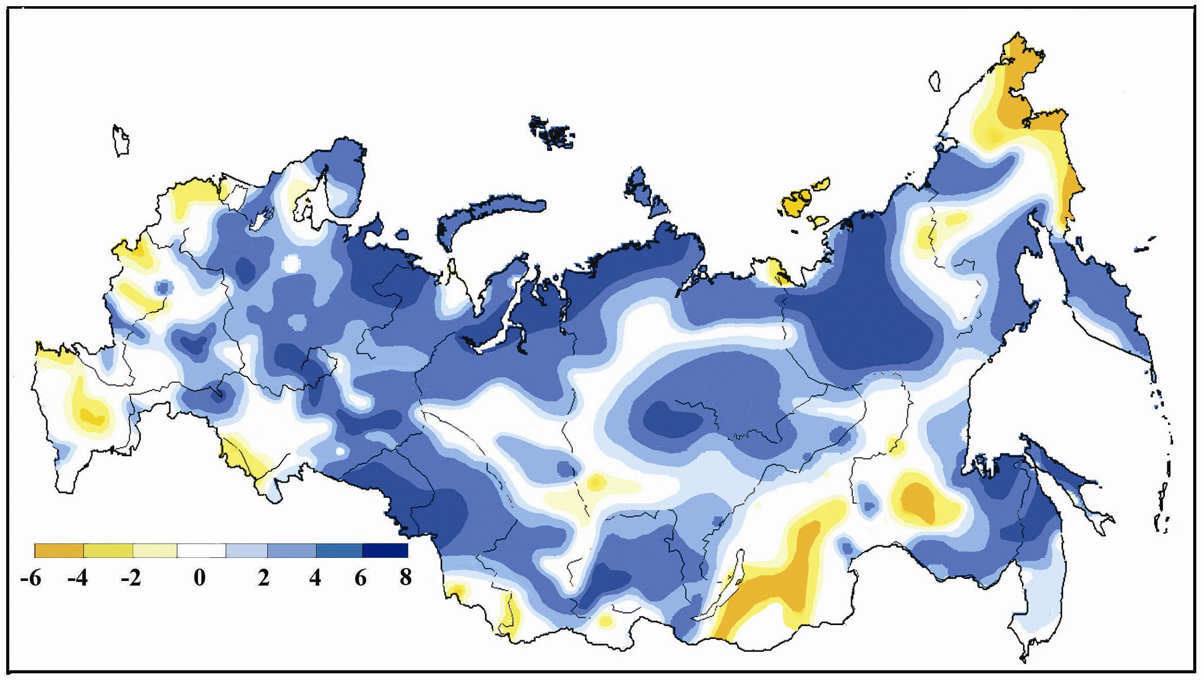

Fig.2. Linear trend coefficients in the time series of the number of days with snow cover exceeding 20 cm for 1951-2006
.
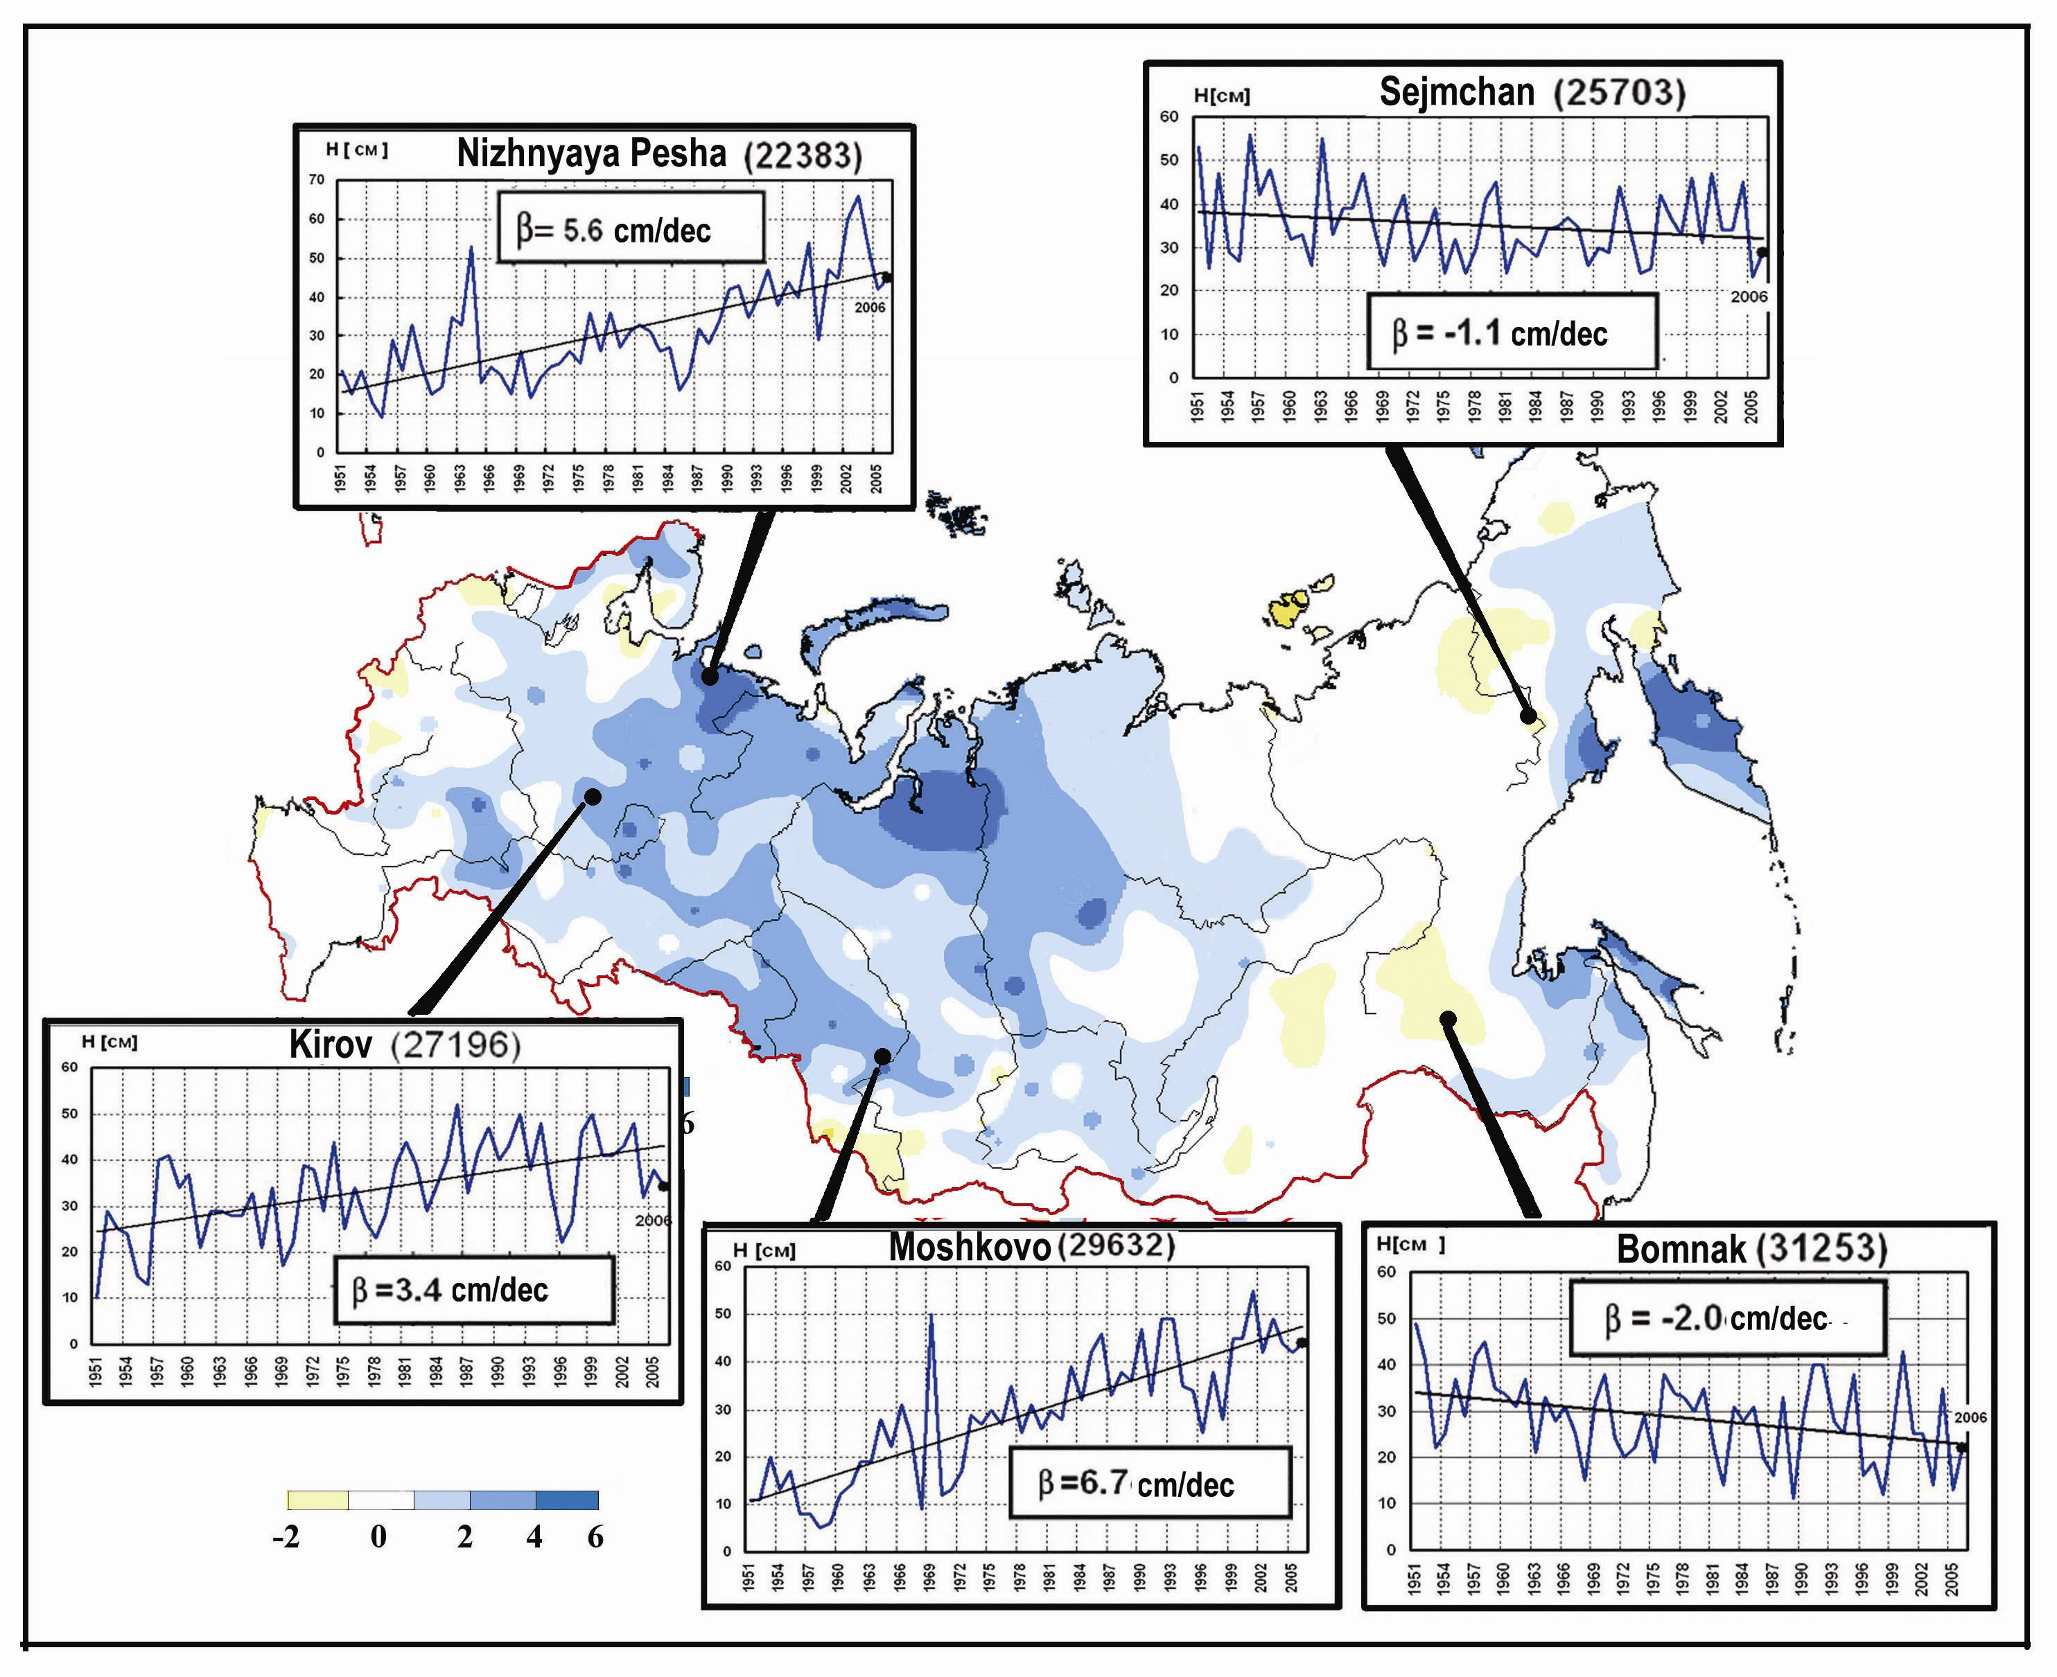

Fig.3. Linear trend coefficients in the time series of mean snow depths for the permanent snow-cover period. 1951-2006

According to the analysis of changes in snow characteristics for the last 30 years (1977-2006), snow cover duration decreases on the European territory, in the south of West Siberia, and in the Amur Region. At the same time in the South Urals, in Tatarstan, Bashkiria and Buryatia the tendency is recorded for the increasing snow duration to 4-6 days/decade. As for the mean winter snow height characteristic, the area with negative linear trend coefficients increased on the European territory and in East Siberia, as compared with the period 1951-2006.

